**DAILY ONLINE ACTIVITIES SUMMARY**

|  |  |  |  |  |  |  |  |  |
| --- | --- | --- | --- | --- | --- | --- | --- | --- |
| **Date:** | **22/05/2020** | | | | | **Name:** | **Archana J C** | |
| **Sem & Sec** | **4th**  **‘A’** | | | | | **USN:** | **4AL18CS011** | |
| **Online Test Summary** | | | | | | | | |
| **Subject** | | **Operating system** | | | | | | |
| **Max. Marks** | | **30** | | **Score** | | | **22** | |
| **Certification Course Summary** | | | | | | | | |
| **Course** | **Python machine learning** | | | | | | | |
| **Certificate Provider** | | | **Great learning academy** | | **Duration** | | | **4-5days** |
| **Coding Challenges** | | | | | | | | |
| 1. **Write a C Program to implement various operations on Singly Linked List Stack.**   **2.Write a C or Java program to implement round robin type of process scheduling** | | | | | | | | |
| **Status: Completed** | | | | | | | | |
| **Uploaded the report in Github** | | | | | **Yes** | | | |
| **If yes Repository name** | | | | | **Lockdown coding** | | | |
| **Uploaded the report in slack** | | | | | **Yes** | | | |

Online Test Details: (Attach the snapshot and briefly write the report for the same)The online test was from operating system module 1, which was about introduction to operating system, operating system services and process management. There were 30 questions each of one mark, duration was 40 minutes. The question were easy to answer. The score that I received was 22/30.

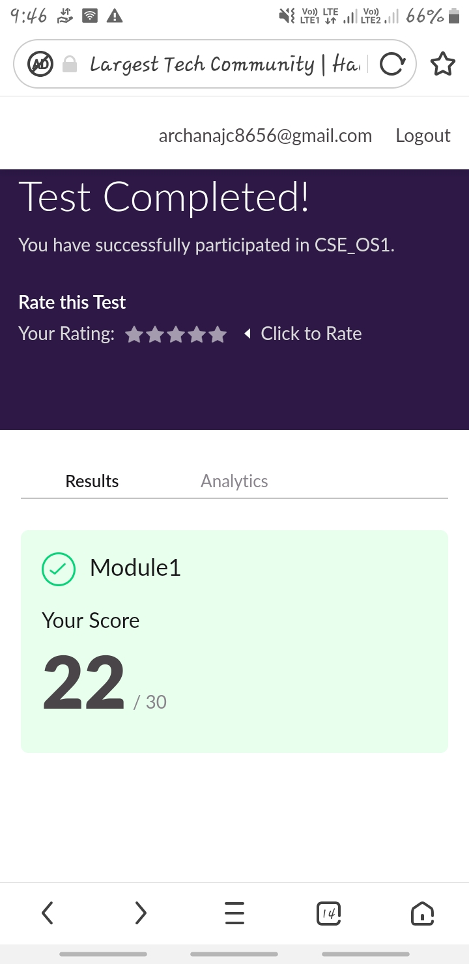

Certification Course Details: (Attach the snapshot and briefly write the report for the same)

CERTIFICATION COURSE : Python machine learning

CERTIFICATION PROVIDER : Great learning academy

Today I learnt how to python code using conditional statements, looping statements and also using functions in python. Then I learnt about introduction about numpy, installation of numpy and saving and loading numpy arrays.

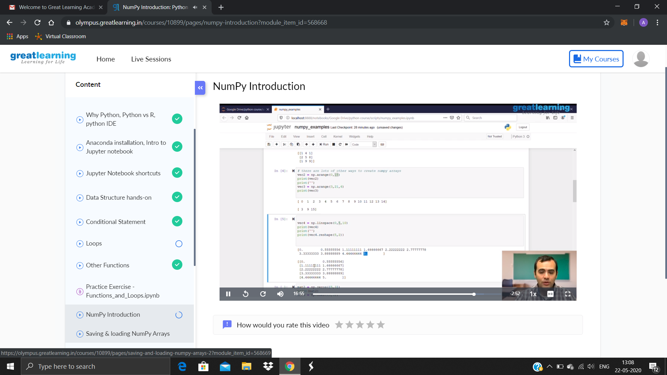

Coding Challenges Details: (Attach the snapshot and briefly write the report for the same)

PROBLEM1 : Write a C Program to implement various operations on Singly Linked List Stack.

Hint: First Create a Singly Linked List Stack with the node corresponding to First Element is the base of the stack; and its link field must be always Null.

When you push First Element, It is the First and it is Base of the stack. Its Link must be Null. top pointer pointing to First. (top = First)

When you push any element, (No need of checking Stack full case because SLL is dynamic) Create a new node called temp using malloc function and insert the a number into Data field, and Link field must be pointing to top; and move the pointer top to point to temp.

When you pop, First check for stack Empty. if First == NULL, then Stack Empty. If it is not empty, The pointer temp must be pointing to top. Move the pointer top to top->link. delete temp.

When you display the stack element, First Check for Stack Empty as in pop operation. If it is not empty, Display all the elements of current stack starting from top to First.

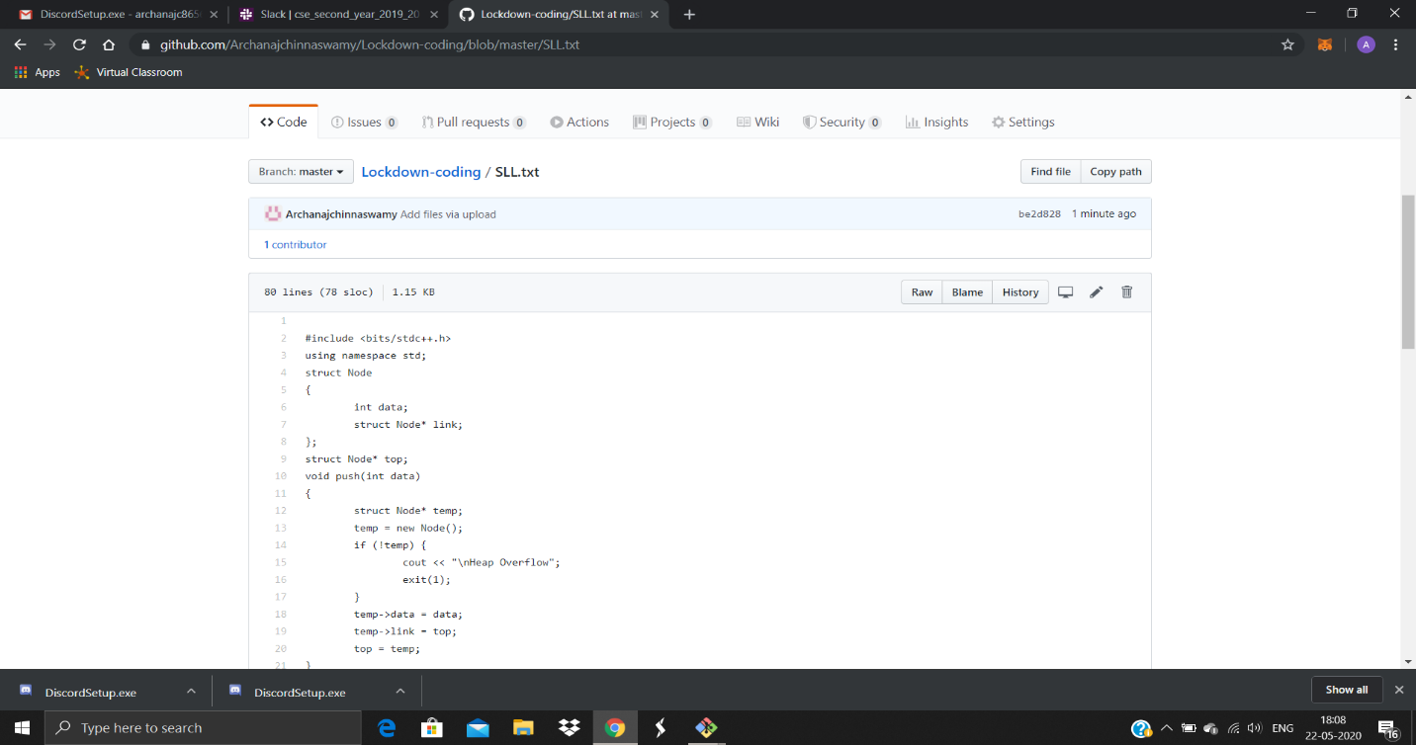

PROBLEM 2 : Write a C or Java program to implement round robin type of process scheduling

Write a C or Java program to implement round robin type of process scheduling.

Input: Process with burst time, arrival time and specify the time quantum

Output: Processes scheduled based on the round robin type of scheduling, with its average waiting time.

